**Configuring your ATV**

On the main screen of your ATV select the 'settings' button:

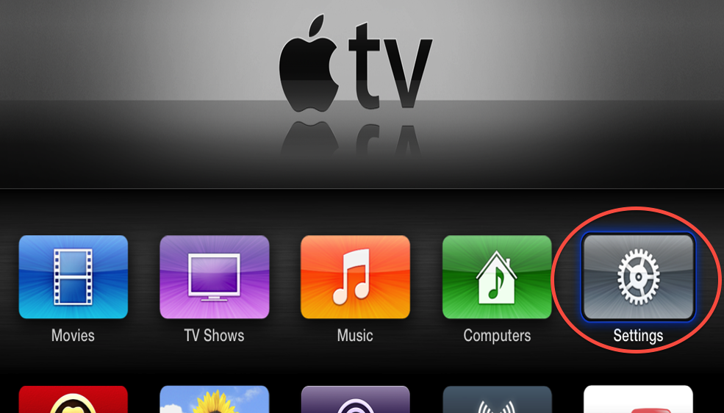

On the settings screen of your ATV select the 'general' button:

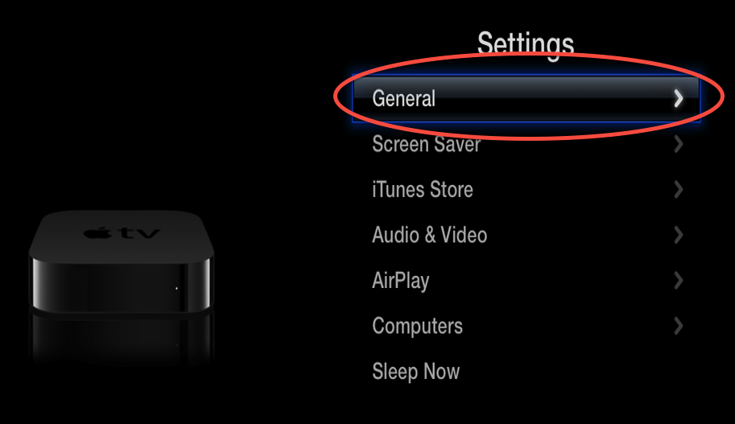

On the general screen of your ATV select the 'network' button:

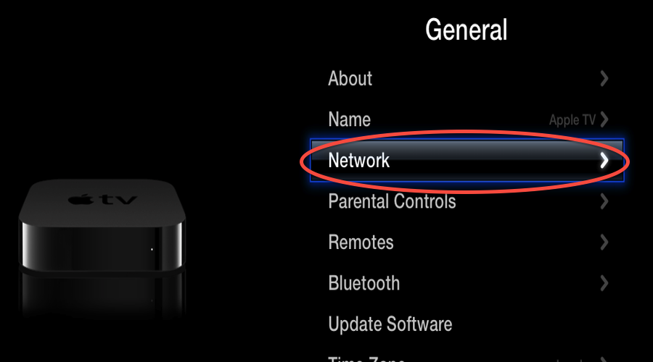

On the network screen of your ATV select the 'ethernet button' (if you are connected via wireless then select that instead):

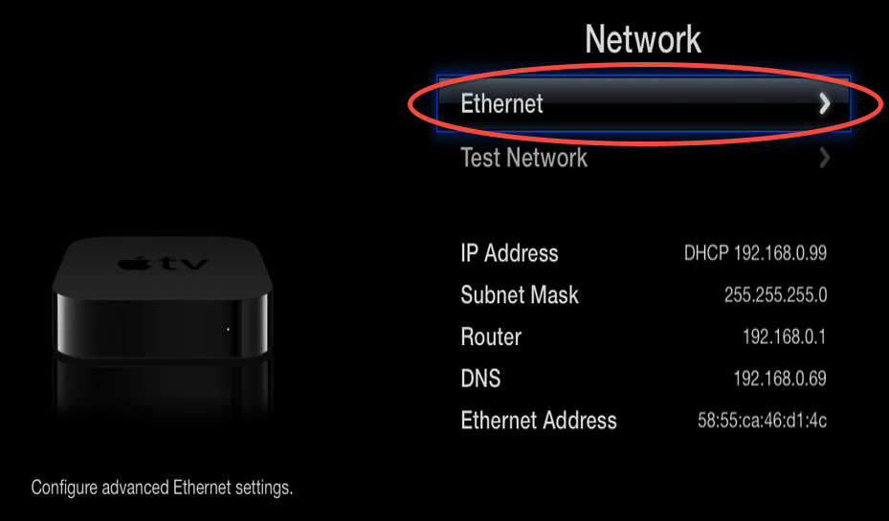

Make a note of the current DNS server as this is needed for one of the optional steps in the advanced setup options, then click on the 'configure DNS' button:

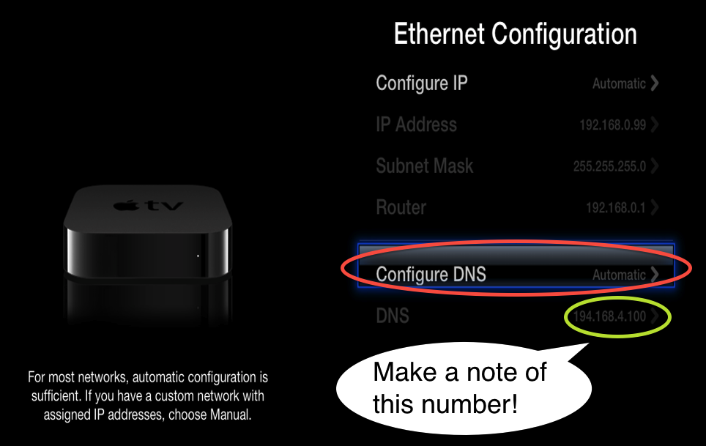

On the 'configure DNS' screen click on the 'manually' button:

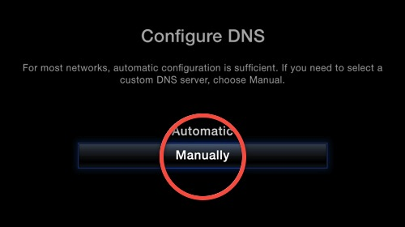

On the 'configure DNS' screen change the IP address to that of the local IP of the device that you are running the PlexConnect application on and then click on the 'done' button (if you are using a firmware prior to 5.2 it may ask you to configure the IP address of your router and the subnet mask, leave them unchanged):

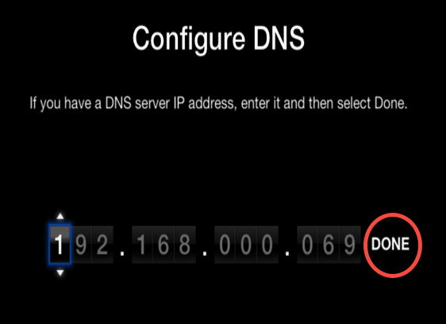

It should return you to the previous network configuration screen, check that the DNS server is set to manual and that the IP address is now that of the machine that you are running PlexConnect on:

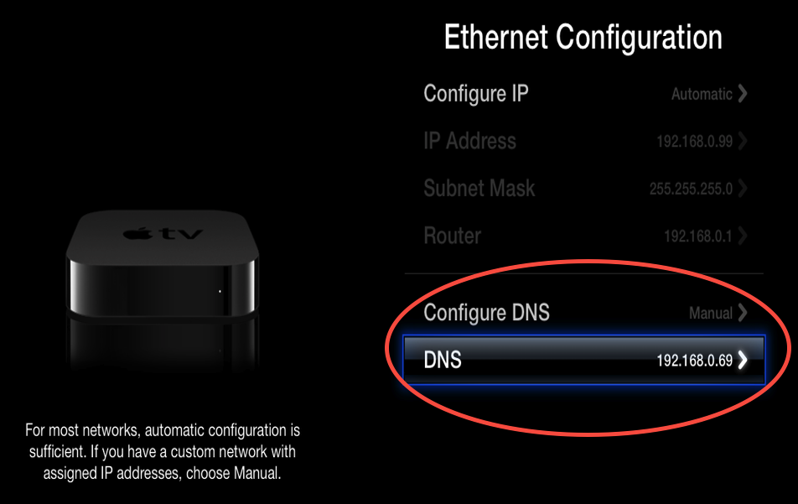

For more details log to [plexconnect](plexconnect.org)

[.org](plexconnect.org) website